1.Output Screenshot for compare 2 JSON have the same properties without order

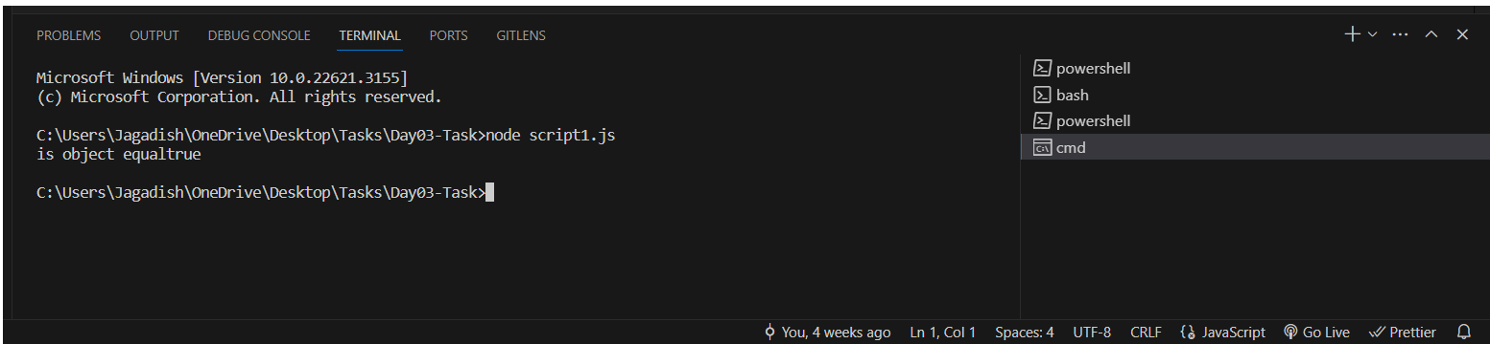

2.Display all the country name, region, subregion, population and flag

